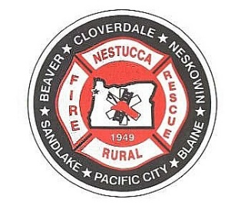

NESTUCCA RURAL FIRE PROTECTION DISTRICT

Agenda

Regular Board Meeting
October 9th, 2024
Station 87 Hebo, Oregon

Turn off all cell phones

All Please Stand for the Pledge of Allegiance

Call to Order: Time: _______

Assure all guests have signed the sign-in sheet.
Note those who will be speaking, the subject and that there is a three (3) minute time limit.
This meeting is recorded

Roll Call: Dorothy Gann _____ Steve Shiels _____ Mark Menefee _____
Shelley Cully ____ Brandon Longanecker_____

Adjustments to Agenda:

Audience Participation: Three (3) minute time limit.

Approval of Minutes: Regular Board of Directors Meeting September 11th, 2024.
Motion to Approve: ____________________ 2nd_________________________
Motion Passed by: Dorothy Gann _____ Steve Shiels _____ Mark Menefee____
Shelley Cully ____ Brandon Longanecker_____

Payment of Bills: Oregon Coast Bank online bill pay, electronic fund transfer, bank charges, petty cash expenditures and LGIP charges, direct deposit payroll and payroll taxes in the total amount of $189,123.94
Motion to Approve: ____________________ 2nd_________________________
Motion Passed by: Dorothy Gann _____ Steve Shiels _____ Mark Menefee____
Shelley Cully ____ Brandon Longanecker_____

Treasurers Report for: September 30th, 2024, funds and account balances of $820,316.98
Motion to Approve: ____________________ 2nd_________________________
Motion Passed by: Dorothy Gann _____ Steve Shiels _____ Mark Menefee____
Shelley Cully ____ Brandon Longanecker_____

Correspondence:
See packet

Old Business
Discuss draft of resolution to adopt cost-based fees and rates for District-provided services.

New Business:
Choose two Board members to be signers for safe deposit box at Oregon Coast Bank
Update accountant LGIP access.

Executive Session Per ORS. 192.610 to 192.690

Reports:
See packet

Good of the Order:

Next Meeting: November 13th, 2024
Agenda Items for Next Meeting:

Adjourn:
Motion to Approve: ____________________ 2nd_________________________
Motion Passed by: Dorothy Gann _____ Steve Shiels _____ Mark Menefee _____
Shelley Culley_____ Brandon Longanecker_____

Time:

