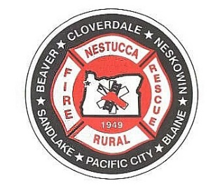

NESTUCCA RURAL FIRE PROTECTION DISTRICT

Agenda

Regular Board Meeting
February 12th, 2025
Station 87 Hebo, Oregon

Turn off all cell phones

All Please Stand for the Pledge of Allegiance

Call to Order: Time: _______

Assure all guests have signed the sign-in sheet.
Note those who will be speaking, the subject and that there is a three (3) minute time limit.
This meeting is recorded

Roll Call: Dorothy Gann _____ Steve Shiels ____ Shelley Cully ____
Mark Menefee _____ Anne Price_____

Adjustments to Agenda:

Audience Participation: Three (3) minute time limit.

Approval of Minutes: Regular Board of Directors Meeting January 8th, 2025.
Motion to approve: ____________________ 2nd_________________________
Motion passed by: Dorothy Gann _____ Steve Shiels ____ Shelley Cully ____
Mark Menefee _____ Anne Price_____

Payment of Bills: Oregon Coast Bank online bill pay, electronic fund transfer, bank charges, petty cash expenditures and LGIP charges, direct deposit payroll and payroll taxes in the total amount of $308,118.59
Motion to approve: ____________________ 2nd_________________________
Motion passed by: Dorothy Gann _____ Steve Shiels ____ Shelley Cully ____
Mark Menefee _____ Anne Price_____

Treasurers Report for: January 31st, 2025, funds and account balances of $2,073,726.39
Motion to approve: ____________________ 2nd_________________________
Motion passed by: Dorothy Gann _____ Steve Shiels ____ Shelley Cully ____
Mark Menefee _____ Anne Price_____
Correspondence:

Old Business
None

New Business:

Executive Session Per ORS. 192.610 to 192.690

Reports:
Station 86 report

Good of the Order:
Station Update
Station 85 seismic upgrade- at point of signing contract with WRK Engineers

Next Meeting: March 12th, 2025
Agenda Items for Next Meeting:

Adjourn:
Motion to Approve: ____________________ 2nd_________________________
Motion Passed by: Dorothy Gann _____ Steve Shiels ____ Mark Menefee _____
Shelley Culley_____ Anne Price_____
Time:

